NOKIA 808 pure view
The 41 megapixel phone
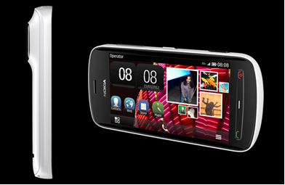
The nokia pure view is a phone that can be simply called insane.
Okay I can say its just like dubai……
in terms of whenever a country comes up with something big, dubai screw’s it and then makes something huge…. Take the burj khalifa for example the height of the building was not disclosed till the final storey of the building was made!!!!!!!!.
Well not deviating from the topic here is a certain myth about megapixels
if you think that the more the megapixels the better the photograph ,then my dear you’re wrong, actually anything above 5 is decent enough to take a good photograph ,if you already knew that then well and good.
Now about the phone, the phone comes with a 41 megapixel image quality, has 1080p (not 1080i, for those of you who don’t know the difference go to http://answers.yahoo.com/question/index?qid=20081112124000AAbaGxc) hd video recording and distortion free recording upto sound levels ranging as high as 120 decibles………..
And the coolest and the best thing Nokia 808 PureView is the first smartphone to feature Dolby® Headphones. It’s exclusive to Nokia smartphones. With Dolby® Headphones you can get Dolby Surround sound from any stereo headphones.
The phone has an amoled (Active matrix organic light-emitting diode) capacitive touch screen and 16 million colours!!!!!!
And now coming to the price of the phone the phone is expected to come to india with a price range of about 30000 rupees.
Okay the phone is a one of kind but it has a lot of competition in this price range the Samsung galaxy s2,sony xperia arc, lumia 800 and a lot of other phones….
The phone all in all has a very good built and a sturdy frame(nokia speciality, my nokia fell from the 3rd floor of my building still working…!!!!) the head where the camera is, is a little fat though just like the nokia n8,an appreciable battey life of 11 hours talk time.
For me this phone is next in my wishlist!!!!!!
-RISHABH GUPTA
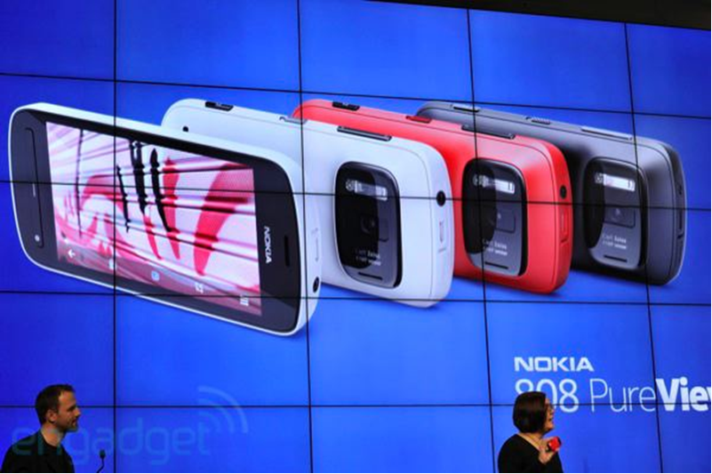
I suggest please do check the website out, it has some awesome videos about the phone…….

